Paper Title
Special Interest Group on Green Information Systems
SIGGreen Pre-ICIS 2023 Workshop

First author’s name  Affiliation  e-mail address | Second author’s name  Affiliation  e-mail address
Third author’s name
Affiliation
e-mail address
or

First author’s name  Affiliation  e-mail address | Second author’s name  Affiliation  e-mail address
Third author’s name  Affiliation  e-mail address | Fourth author’s name  Affiliation  e-mail address

Abstract (Required)
In this document we describe the formatting requirements for the Pre-ICIS 2023 Workshop. It a small adaptation from the regular ICIS template. Please review this document carefully. You can use this document as a template and copy/paste your paper content here (this might be the best or easiest way). Please be sure to adhere to the formatting requirements as this will be your camera-ready version, and a PDF format will be generated directly from your submitted final Word version. Your completed extended abstract is limited to title page + 2 pages + references.

Keywords (Required)

Introduction
We ask that authors follow these basic guidelines when submitting to ICIS. In essence, you should format your paper exactly like this document. The easiest way to use this template is to replace the placeholder content with your own material. The template file contains specially formatted styles (e.g., Normal, Heading, Bullet, References, Title, Author, Affiliation) that are designed to reduce the work in formatting your final submission.

Page Size and Spacing
On each page, your material (not including the header and footer) should fit within a rectangle of 16.5 x 22.8 cm (6.5 x 9 in.), centered on a US letter page, beginning 1.27 cm (0.5 in.) from the top of the page. Please adhere to the US letter size only (in MS Word, you can check the page format in the menu: File --> Page Setup). If you cannot do so, please contact the review coordinator for assistance. All final publications will be formatted and displayed in US letter size. Right margins should be justified, not ragged. All margins must measure 1” (2.5 cm) around. Beware, especially when using this template on a Macintosh, Word may change these dimensions in unexpected ways.
Please ensure your manuscript complies with the following instructions:
- Line spacing should be single (exactly 1.0);
- Margins should be 1 inch (2.54 cm);
- Do not change character or word spacing;
- Please do not use double spaces between sentences – this is a tradition no longer necessary on modern word processors;
- Please do not edit the styles in this template;
- Please ensure all text is justified, not “ragged” ( = left-aligned).
Non-compliance of these instructions may lead to desk rejection of your paper.

Length
Your completed extended abstract is limited to
- title page + page break
- max. 2 pages text including all figures and tables + page break
- references
Any submission that exceeds page length limits will be rejected without review.

Title
Your paper’s title should be using the “Title” style in this template (which is configured as Georgia 20-point bold). Ensure proper capitalization within your title (i.e. “The Next Frontier of Information Systems” versus “the next frontier of Information systems.”
All proper nouns should be capitalized. Articles (the, a), coordinating conjunctions (and, but, or, for, nor, etc.) should not be capitalized, unless, of course, they are used as the first word in the title. Likewise for prepositions (on, at, to, from, by, etc.).

Normal or Body Text
Please use the “Normal” style for normal text – this style is configured as a 10-point Georgia font (similar to Times New Roman, but more easily read online) or, if it is unavailable, another proportional font with serifs, as close as possible in appearance to Times New Roman 10-point. Please use sans-serif or non-proportional fonts (such as Arial or Courier) only for special purposes, such as source code text (SpecialStyle). [References to Georgia font from this point forward should be interpreted as “Georgia or equivalent.”]

Sections
The heading of a section should be using the “Heading 1” style – configured as Georgia 13-point bold, left justified. Sections should not be numbered.

Subsections
Headings of subsections should be using the style “Heading 2” – configured as Georgia 11-point bold italics with initial letters capitalized. (Note: for sub-sections and sub-subsections, words like ‘the’, ‘of’, ‘a’, ‘an’ are not capitalized unless it is the first word of the heading.)

Sub-subsections
Headings for sub-subsections should be using “Heading 3” – configured as Georgia 10-point bold with initial letters capitalized. Please do not go any further into another layer/level.

Figures, Tables & Captions
Place figures and tables close to the relevant text (or where they are referenced in the text).
Captions should be using the “Caption” style – configured as Georgia 10-point bold. They should be numbered (e.g., “Table 1” or “Figure 2”), centered and placed beneath the figure or table. Please note that the words “Figure” and “Table” should be spelled out (e.g., “Figure” rather than “Fig.”) wherever they occur. The proceedings will be made available online, thus color figures are possible.

Inserting Images
Occasionally MS Word generates larger-than-necessary PDF files when images inserted into the document are manipulated in MS Word. To minimize this problem, use an image editing tool to resize the image at the appropriate printing resolution (usually 300 dpi), and then insert the image into Word using Insert | Picture | From File...
As indicated in Figure 1, using tables to hold places can work very well in Word. If you want to copy a figure from another application (such as PowerPoint) and then paste to the place where you want your figure to be, make sure that (1) the figure stays in the position, and (2) it does not take up too much space. You can ensure the former by double clicking the figure, then go to “Layout” tab, and select “In line with text.” To ensure the latter, use “Paste Special,” then select “Picture.” You can resize the figure to your desired size once it is pasted.

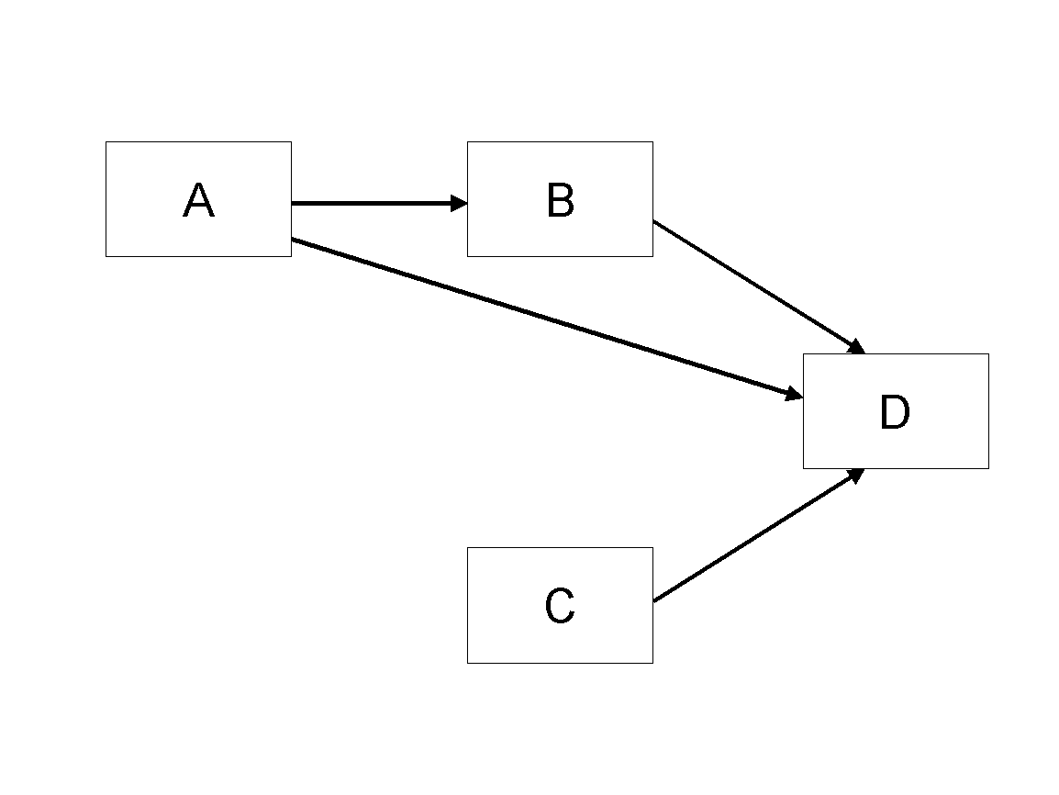
Figure 1. Modified Research Model

Table Style
Inserting a table in the text can work well. You may want to adjust the vertical spacing of the text in the tables. (In Word, use Format | Paragraph… and then the Line and Page Breaks tab. Generally, text in each field of a table will look better if it has equal amounts of spacing above and below it, as in Table 1.)
 | Treatment 1 | Treatment 2
Setting A | 125 | 95
Setting B | 85 | 102
Setting C | 98 | 85
Table 1. A Very Nice Table

Other Visual Media (e.g., video clips)
Submissions that rely on the use of visual media such as video, animation, visual analytics, etc., should embed links to these in their submission pdf. The visual media portion of the submission should be no more than 5 minutes (in total). Given the limitations of the review system, the visual media portion of the paper must be hosted outside the review system. We ask each author to create his/her own account with an open access provider of choice (e.g., linked video could be hosted in Vimeo or YouTube). Please use a pseudo user name in order to maintain anonymity during the review process. The visual media portion of the submission must be playable in a generic Internet browser. Please fine-tune for Firefox. Please verify that all links to visual media work as expected in the system-generated PDF prior to submitting the paper to the review system. Do not change your online media after submitting the paper for review. We recommend using Creative Commons Licenses for the visual media portion of the submission. If you have any other questions, please contact the program co-chairs.

Language, Style, and Content
With regard to spelling and punctuation, you may use any dialect of English (e.g., British, Canadian, US, etc.) provided this is done consistently. Hyphenation is optional. To ensure suitability for an international audience, please pay attention to the following:
- Write in a straightforward style.
- Try to avoid long or complex sentence structures.
- Briefly define or explain all technical terms that may be unfamiliar to readers.
- Explain all acronyms the first time they are used in your text – e.g., “primary care provider (PCP)”.
- Explain local references (e.g., not everyone knows all city names in a particular country).
- Be careful with the use of gender-specific pronouns (he, she) and other gendered words (chairman, manpower, man-months). Use inclusive language that is gender-neutral (e.g., they, s/he, chair, staff, staff-hours, person-years).

Conclusion
It is important that you write for a general audience. It is also important that your work is presented in a professional fashion. This guideline is intended to help you achieve that goal. By adhering to the guideline, you also help the conference organizers tremendously in reducing our workload and ensuring impressive presentation of your conference paper. We thank you very much for your cooperation and look forward to receiving a professional looking, camera-ready version!

Acknowledgements (optional)
Please do not add acknowledgements to your original submission because it will help identify authors. Acknowledgements may be added later, if the paper is accepted.

References and Citations
References are to be formatted using the new MIS Quarterly style (http://www.misq.org/manuscript-guidelines under MISQ References Format). References must be complete, i.e., include, as appropriate, volume, number, month, publisher, city and state, editors, last name & initials of all authors, page numbers, etc. If you use EndNote, be aware that different versions of the software change the styles, creating some inconsistencies. Please also be aware that the MIS Quarterly style provided by default in the EndNote X4 software (and all earlier versions) is for the old MIS Quarterly style. You may access the End Note Style here.
Your references should comprise only published materials accessible to the public. Proprietary information may not be cited.
References should be ordered in alphabetic order.

References

<<<Please ensure that all references are present, complete, and accurate as per the examples below.>>>
Ackoff, R. L. 1961. "Management Misinformation Systems," Management Science (14:4), pp. 147-156.
Benbasat, I., and Zmud, R. W. 2003. “The Identity Crisis within the IS Discipline: Defining and Communicating the Discipline’s Core Properties,” MIS Quarterly (27:2), pp. 183-194.
Bonini, C. P. 1963. Simulation of Information and Decision Systems in the Firm, Englewood Cliffs, NJ: Prentice-Hall.
Broadbent, M., Weill, P., O’Brien, T., and Neo, B. S. 1996. “Firm Context and Patterns of IT Infrastructure Capability,” in Proceedings of the 14th International Conference on Information Systems, J. I. DeGross, S. Jarvenpaa, and A. Srinivasan (eds.), Cleveland, OH, pp. 174-194.
Carroll, J. 2005. “The Blacksburgh Electronic Village: A Study in Community Computing,” in Digitial Cities III: Information Technologies for Social Capital, P. van den Besselaar and S. Kiozumi (eds.), New York: Springer-Verlag, pp. 43-65.

