Mobile testing centers – The COVID-19 Virus

Due to their remoteness and lack of medical supplies, 21 Western OK counties have been designated to serve as potential hosting sites for mobile Coronavirus testing. The map below depicts those 21 counties.

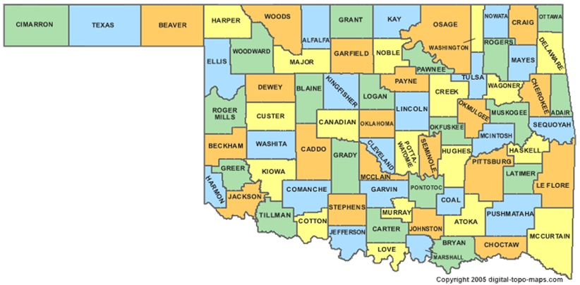

The following table shows the county name, its population, the cost to locate an MTS (mobile testing site) in that county, and then a measure of how severe or how unknown the severity of the virus is in that county.



A supplemental file will be provided that shows the ‘contiguity’ table for counties – counties that are ’next’ or adjacent to each other.

Your task as a modeler – find the optimal location of which counties to locate MTS’s such that the following requirements are met.

1. Each county is ‘covered’ – traditional definition of a set covering problem. A county is covered when either an MTS is located int hat county or in an adjacent county.
2. Each county has a maximum number of ‘coverage’ – i.e. – overlap. Initially, allow up to 3 different MTS’s to cover a particular county.
3. At least 50% of the MTS’s must be placed in counties with populations less than 10,000.
4. The total cost of the MTS’s cannot exceed 125 units.
5. The weighted average of the COVID severity county measures where MTS’s are located must be >= 2.7.

Your objective measure (objective function) in determining which counties should house an MTS subject to these requirements is a function of its population plus a proportion (25%) of the population of the counties that are contiguous. For example, look at Grant county.

Grant = 5144, it is next to Garfield (57813) and Alfalfa (6105). So Grant’s WPOM (weighted population measure) would be 5144 + (0.25)(57813) + (0.25)(6105) = 21123.5.

The location of the MTS’s should maximize the WPOM parameter.

Compare this solution to two more scenarios (B and C).

Scenario B: Instead of using WPOM, use just the main county population. All other model parameters constant.

Scenario C: Using WPOM, alter constraint 2) above to limit the maximum coverage of any county to at most 2.

Compare the original solution to Scenario B and C. Nothing elaborate. They should be similar but a little different.

Version 1: 4/6/20